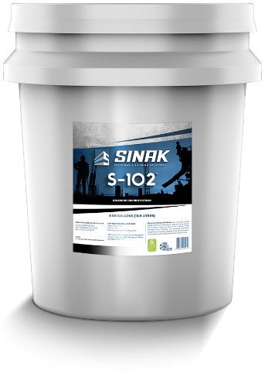**SUBMITTAL PACKAGE**

**PLEASE COPY THE TEXT BELOW AND PASTE INTO A NEW EMAIL ___________________________________________________________**

**SINAK S-102** is a zero VOC permanent penetrating waterproofing sealer and salt guard. Concrete treated with S-102 is permanently protected against water penetration, de-icing agents, chloride intrusion (salts), efflorescence, and freeze-thaw conditions. S-102 will not need to be re-applied for the life of the concrete, making it an excellent choice to preserve and protect exterior concrete while dramatically reducing maintenance costs.

S-102 is class 55 non-hazardous, non-toxic, contains no solvents, and is listed as UL GREENGUARD Gold Certified, LBC Red List Free, Super Compliant with SCAQMD, and Buy American Act compliant.

**Supporting Documentation:**

[Technical Datasheet - S-102](https://sinak.com/wp-content/uploads/2022/11/SINAK-S-102-Sealer-Technical-Data-Sheet.pdf)  
[MSDS - S-102](https://sinak.com/wp-content/uploads/2022/11/SINAK-S-102-SDS.pdf)  
[Product Specification - S-102](https://sinak.com/wp-content/uploads/2022/11/SINAK-S-102-Sealer-Product-Specification.docx)

Please let me know what questions I can answer for you, if any.